Checkpoint MongoDB

* Cérate a data base called "contact" and Cérate a collection called "contactlist” :

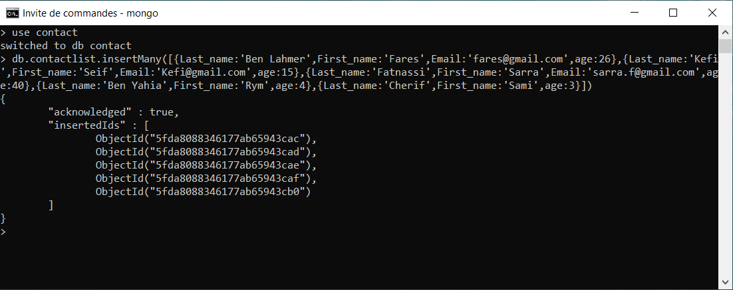

1- Display all the information about only one Person using his id :

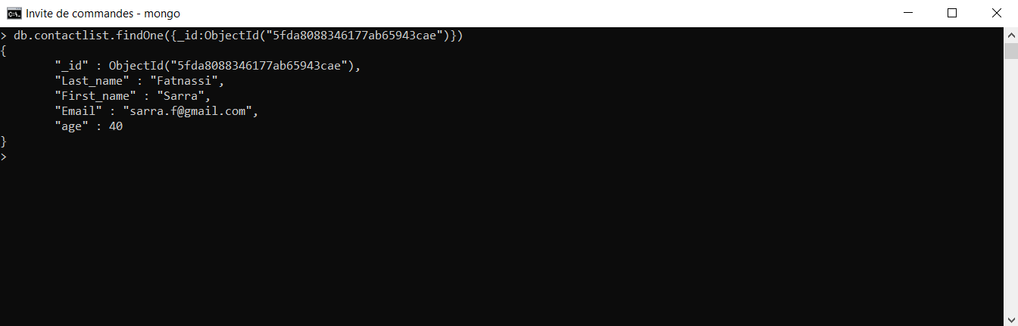

2- Display all the contact list having age>18 :

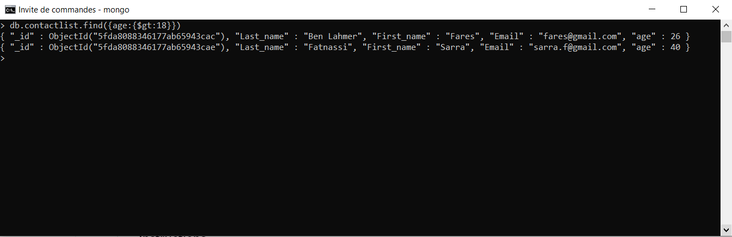

3- Display all the contact list having age>18 and name containing "ah" :

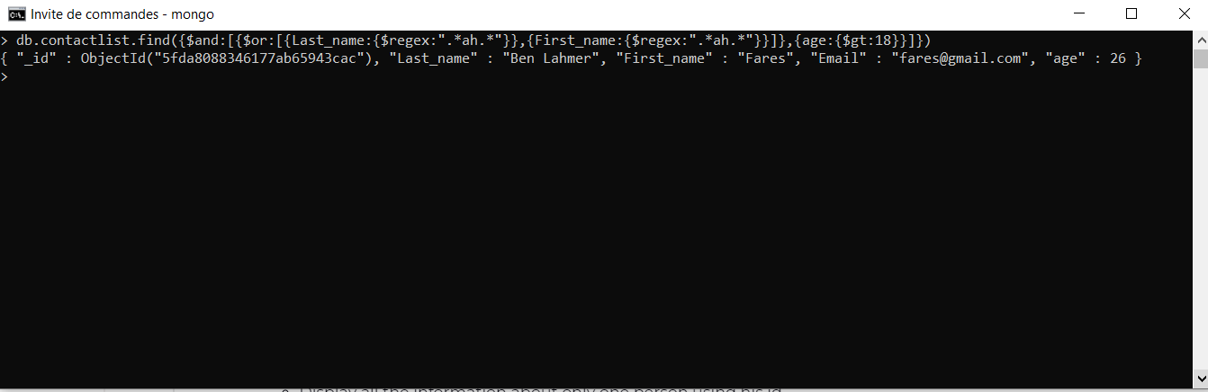

4- Change the contact first name of "kefi Seif" by "Kefi Anis" :



5- Delete the the contact list having age < 5 :



6- Display all the contact list :

